I found two additional datasets, but they’re pretty small (car and globe).

Could also turn these two datasets into multitable ones:
https://www.kaggle.com/datasets/yasserh/wine-quality-dataset
https://www.nyc.gov/site/tlc/about/tlc-trip-record-data.page

Car dataset – pretty small but has continuous variables and predictors. https://data.world/dataman-udit/cars-data
Target variable: price
Direct variables: mpg, cylinders, displacement, horsepower, weight, acceleration, model, origin
Indirect variables:
- Combinations of these variables (displacement / horsepower, mpg / weight, etc.)
- Whether the origin country produces a high or low number of cars
- Whether the model was produced before or after a certain year
GPT 4o:
Power-to-Weight Ratio: horsepower / weight
Engine Efficiency: displacement / horsepower
Performance Index: horsepower * acceleration
Size-to-Weight Ratio: displacement / weight
Efficiency Index: mpg * horsepower
Cylinder-Weight Ratio: cylinders / weight
Acceleration Index: acceleration / weight
GLOBE dataset – has many social characteristics of countries on a continuous scale that we can use to predict GDP.
https://globeproject.com/study_2004_2007%3Fpage_id=data.html#findings
Target variable: GDP
Direct variables: How much the country values… charismatic leadership, team-oriented leadership, participative leadership, humane-oriented leadership, autonomous leadership, self-protective leadership, performance orientation, assertiveness, future orientation, humane orientation, institutional collectivism, in-group collectivism, gender egalitarianism, power distance, uncertainty avoidance
Indirect variables:
- Create multiplicative indices for:
  - Collectivism vs. autonomous orientations (team-oriented leadership * participative leadership * institutional collectivism), (autonomous leadership * performance orientation * assertiveness)
  - Egalitarianism vs. individualism on a societal level
  - Individual traits (i.e. charisma) vs. collective traits
  - Protectiveness vs. future orientation
GPT 4o:
- Sum of leadership values
- Index representing progressive cultural values: gender egalitarianism, future orientation, institutional collectivism
- Economic stability index: uncertainty avoidance, power distance, self-protective leadership
- Innovative potential index: performance orientation, assertiveness, autonomous leadership
- Social cohesion index: humane orientation, institutional collectivism, in-group collectivism
- Cultural adaptability index: future orientation, uncertainty avoidance, institutional collectivism
I had some issues with multicollinearity with direct variables in the new datasets, so I did some experimenting…
I modified the VIF function that checks for multicollinearity to add a constant each time it runs, which theoretically should mimic the R function more closely (the Python function was intended to be passed a matrix with a constant already added).
A note that features with 0 variance should be removed from datasets before performing linear regression.
I also tried another model, Elastic Net, which reduces multicollinearity in and of itself and sets non-important features to 0. If the parameters are optimized well, it does better than Linear Regression (as measured by a lower MSE score and higher R^2 score) on pretty much every case I’ve tested it on so far. The coefficients can also be interpreted like a linear regression model (i.e. they show relationships between target variables and predictors).
The most important features seem completely different from Linear Regression versus Elastic Net. If Elastic Net can be parametrized correctly, I’d lean towards it as the most generalizable model over many different continuous datasets because it is robust to multicollinearity and has built-in regularization for overfitting as well as feature selection.
I also tried PCA before running Linear Regression, but that didn’t seem to have a significant impact as there aren’t many predictors in most of these datasets.
Examples of Linear Regression vs. Elastic Net:
2015 GDP dataset (GDP in 2015 dropped), Linear Regression
Test MSE: 8,923,224,168,416
Variance of test target column: 272,000,955,979
Test R^2: -33.36
With PCA, test R^2: -31.065
Elastic Net:
Test MSE: 5,986,476,268,387
Test R^2: -22.05
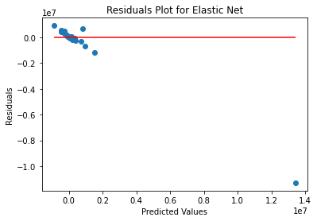
This plot demonstrates the issue with fitting a linear predictor to this dataset: there’s an outlier that significantly skews the predictions. Removing the outlier may have an impact on the accuracy.
Elastic Net does do slightly better at predictions based on MSE and R^2.
2015 indirect variables, GDP, linear regression:
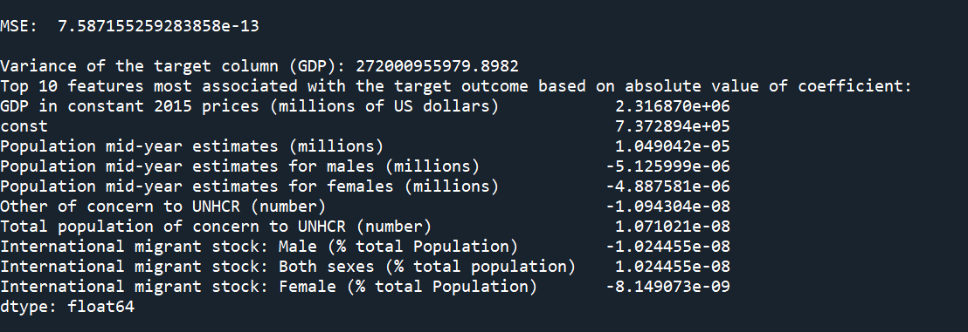
Elastic Net:
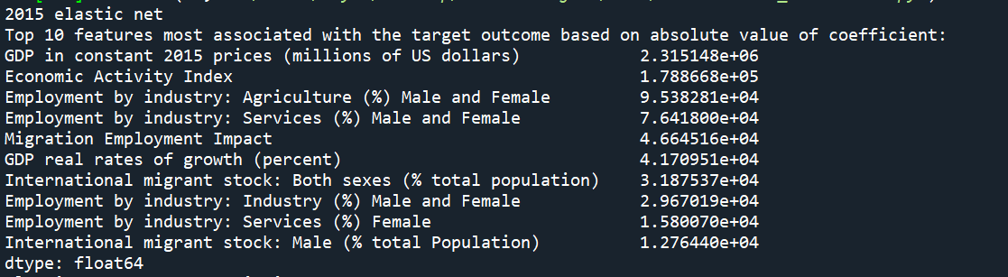
A comparison of R^2 values shows that Elastic Net once again performs slightly better.
AirBNB data, Linear Regression:
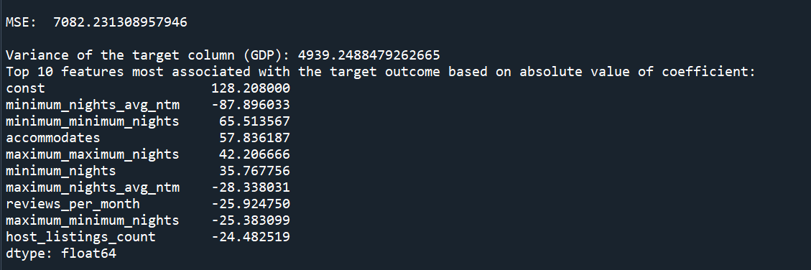
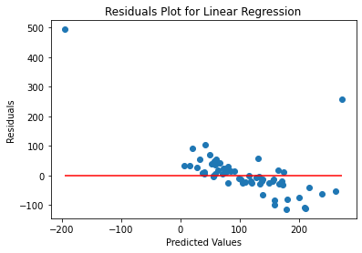
PCA does improve the test MSE but not as significantly as Elastic Net.
Elastic Net:
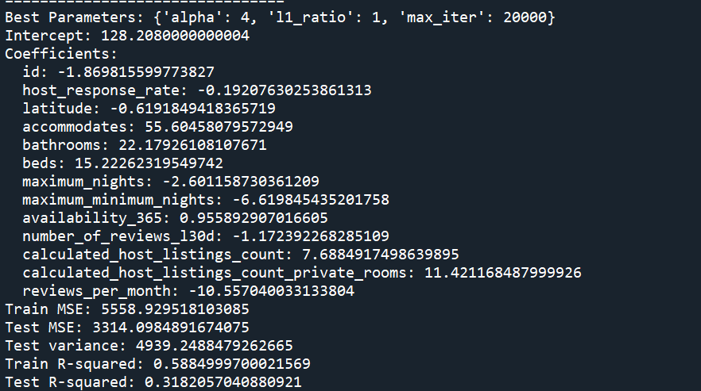
Elastic Net does much better here based on R^2.
The residuals plot also shows that this approach is more appropriate than in the previous dataset.
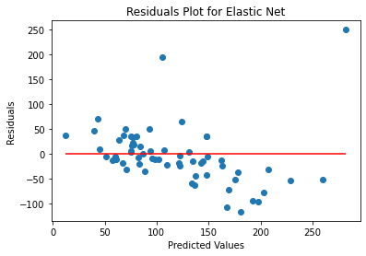
Adding indirect variables:
Linear regression:
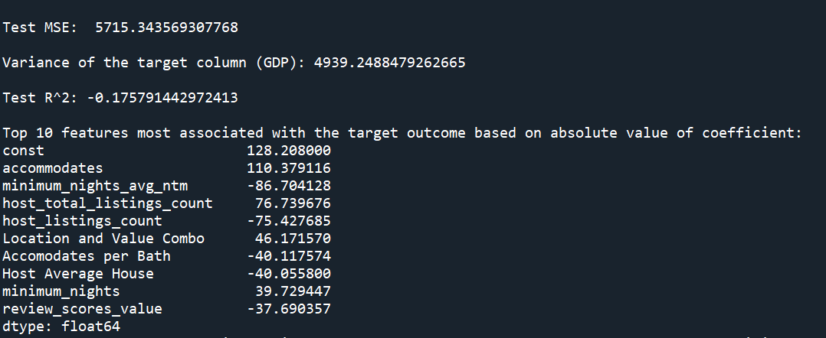
Elastic Net (once again does better w/ R^2 of .31):
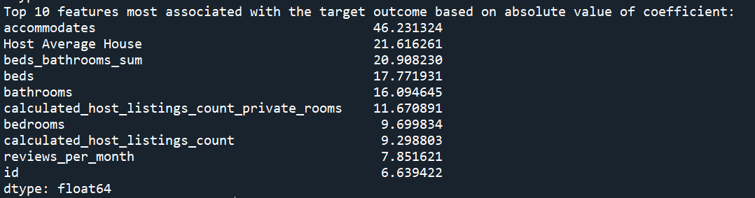
Car dataset (has a very high error, I suspect if this dataset had more observations the regression would do a better job at predicting), linear regression:
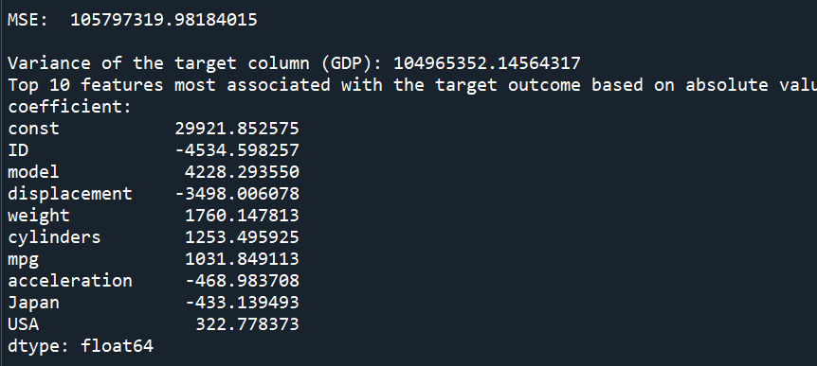
Elastic Net:
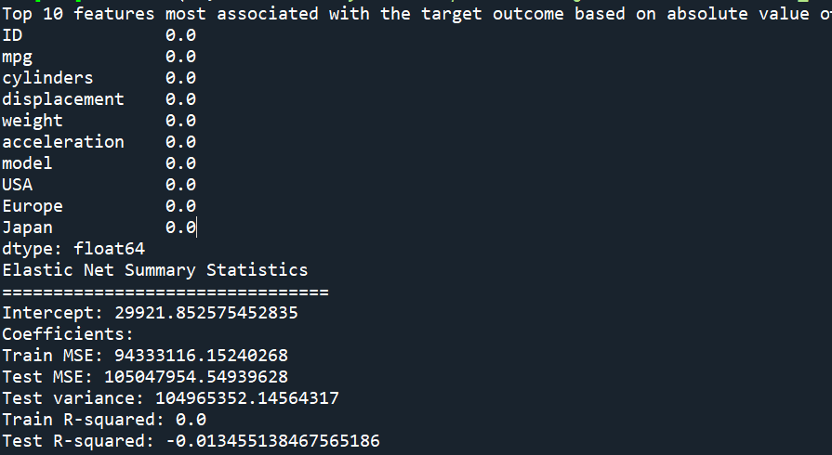
In this case, the coefficients all zeroing out demonstrates that none of our variables have any value in improving the basic prediction of averaging all the data. In other words, none of our variables are valuable predictors.
Indirect variables, linear regression:
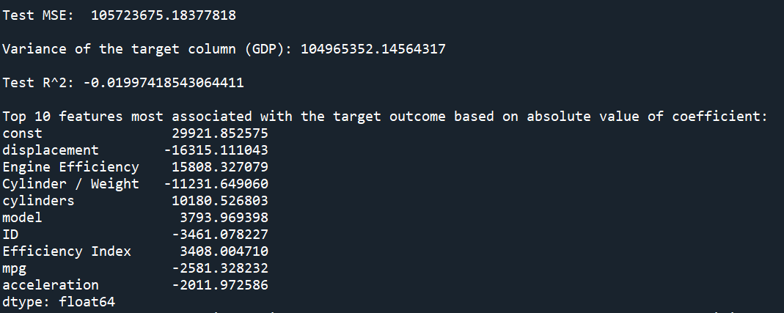
Elastic Net (once again outperforms Linear Regression):
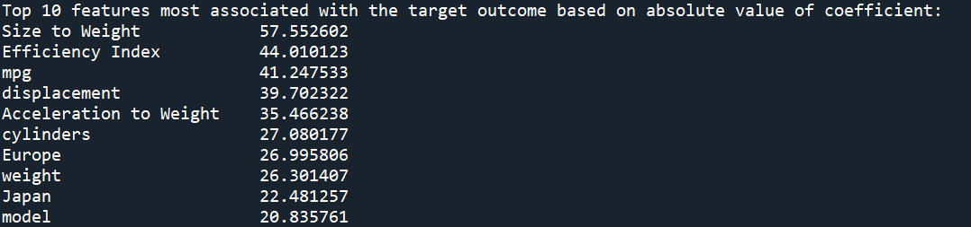
I also tried CatBoostRegressor, but the results were typically worse than Linear Regression and Elastic Boost. I would probably stick to CatBoost for classification only.
Even though Elastic Net does better than Linear Regression, I wouldn’t say that the results are astounding. I think if assumptions are met and the dataset is large enough, the model would do well, but it might require some further validation from the user/human-in-the-loop moments to ensure that assumptions are met (checking for outliers, log-transforming data if needed, etc.). I didn’t try looking at the distributions of each feature and transforming it if needed… that could be an additional step to include.
This is a helpful resource as well: https://www.qualtrics.com/support/stats-iq/analyses/regression-guides/interpreting-residual-plots-improve-regression/#ExaminingPredictedResidual
LLMs and AirBNB data:
GPT 4o: https://chatgpt.com/share/4cdbf8ae-59d5-497f-bf75-bbcf30f2ad98
- When asked to find the best predictors of price, first goes to vanilla linear regression (without checking for multicollinearity), requires prompting to go to elastic net
- Requires prompting for the correct order of train/test split, then scaling data, then making predictions
- Creates good combinations of variables (better than the last time I asked) – model performs better than mine when looking at R^2 (but not MSE… not sure what’s going on there as the calculation seems correct)
  - Total room count
  - Accommodations density
- Overall steps after prompting look pretty much identical to mine
Julius:
- After prompting, creates several variables… some are simple linear combinations of existing variables (not interesting) and some are strange (reviews per bed, reviews per bath)
- Checks VIF after prompting
- Looks at ridge or lasso rather than elastic net (would recommend elastic net as it is the best of both ridge and lasso regression) for controlling multicollinearity
  - Sure enough Elastic Net performs the best (though still has a higher MSE than my model – 3850 compared to ~3300)

Copilot:
- Has trouble merging datasets and creating variables given information present in the dataset itself
  - Creates two variables: total number of rooms and price per room
- After prompting, determines that elastic net is better than lasso
- Brings up RFE as a feature elimination technique which other models haven’t mentioned (I didn’t include it in my workflow but it’s interesting)

